**Cash 4 you review**

Cash 4 you is a Canadian lender that offers services revolving around installment loans, payday loans, cheque cashing, and online money transfer. The loan application can both be done online or in any of their 100+ stores across the Ontario region.

Cash 4 You reviews will be based on the services provided.

**Cash 4 You installment loans**

An installment loan is a loan type that is paid back in divided periods. That is, you'll be paying the loan in a set of payments that is mostly monthly based. This set of payments are the ones called installments hence its name.

**Features of installment loans at Cash 4 You**

* **No need to have an excellent credit**

It's possible to get a loan even with poor credit. The Cash 4 You lender has money solutions for all types of credits. Cosigners are not allowed.

* **You can either apply for a loan over the internet or at their store.**

If you are the lazy type like me who doesn't like traveling a lot, the online application method is perfect. That is because you can apply it anywhere and at any period of the day.

You can also visit their stores which are spread across Ontario region for the loan application.

* **The loan has requirements**

During loan application, you’ll be obliged to meet certain requirements including:

* Be a resident in the Ontario region.
* Have a government ID
* Be 18 years old or above.
* Have a working bank account
* Proof of regular income source

You must meet these requirements to get approved for the loan. Otherwise, you can be rejected.

* **High-interest rates**

The loan has fixed interests which means the interest does not change over time hence planning for it is possible. However, the loan interest is high at 46.93%.

* **There are no prepayment penalties**

If you wish to pay the loan back before the set due date, you can do so without incurring any costs. This is especially advantageous in payday loan repayments.

* **The loans have a limit**

The installment loan limit at Cash 4 You range between $1,000 and $15,000. The loan will mostly depend on your income capacity. Hence, if you have a high income you can borrow large amounts up to $15,000.

* **Borrowers discharged from bankruptcies can be considered**

If you are bankrupt, just know that you'll be directly rejected by the Cash 4 You lender. The lender can only consider you after being discharged from bankruptcy.

**How are the installment loan repayment made at Cash 4 You?**

The set payments are automatically deducted from your account once the due date is reached. This is one of the privacy policies that the lender allows. It’s always recommended you read the privacy policy before filling the application form.

You can also make further payments at any of their stores in Ontario.

**How long does the installment loan approval take?**

When you complete the loan application and get verified, you’ll need to visit any of the stores for document verification and to finalize the agreement. This can be a disadvantage for those in far places.

You will be funded once the verification and finalization process is over.

**Cash 4 You Payday Loans**

A payday loan is a short-term loan type paid mostly after a month or within the next salary date.

**Features of payday loans at Cash 4 You**

* **The application can be done in physical stores or online**

For those who are near the stores, it may be easier to apply for the loans physically due to the short distance. But for those who are at a far distance, the online application will be best suited.

* **There are requirements to be met**

These requirements include:

* The borrower should be employed and be making at least $250 per month.
* The borrower should be 18 years or above.
* The borrower should have a government ID.
* A working bank account is required.
* A working telephone line is also needed.
* Proof of Ontario residency is mandatory.
* **Collaterals are not required**

Collaterals are valuable items you secure a loan with. The Cash 4 You lenders don’t need the collateral during application. Also, credit reports are not checked during the application.

* **Loan approval is short**

If you applied for the loan in a physical store, the loan will be granted immediately after approval is done. You can either get the loan in cash or let it be deposited in your account.

For online borrowers, the loan will be granted within an hour after approval is confirmed. The maximum payday loan limit at Cas 4 You is $1,500.

**How are the Cash 4 You payday loans repayment made?**

After approval, the due date for loan repayment will be communicated. Cash 4 You have two options for repaying the loan which includes:

* Paying in cash or debit at any of the stores in Ontario.
* Accept the automated bank withdrawal method

**Cheque cashing at Cash 4 You**

Cheque cashing is done in any of the Ontario stores for any amount one may need. A government ID will be required for the service. The most common types of cheques cashed include:

* Government Tax Refund
* Payroll
* Money Orders
* Insurance Settlement

**Money Transfer at Cash 4 You**

Cash 4 You use Western Union to send and receive money for the customers. Get more information about these services on their official website.

**What other people say about Cash 4 You**

It’s always a good idea to check what other customers say about a product before using it. Let’s check some of these responses from Trustpilot.

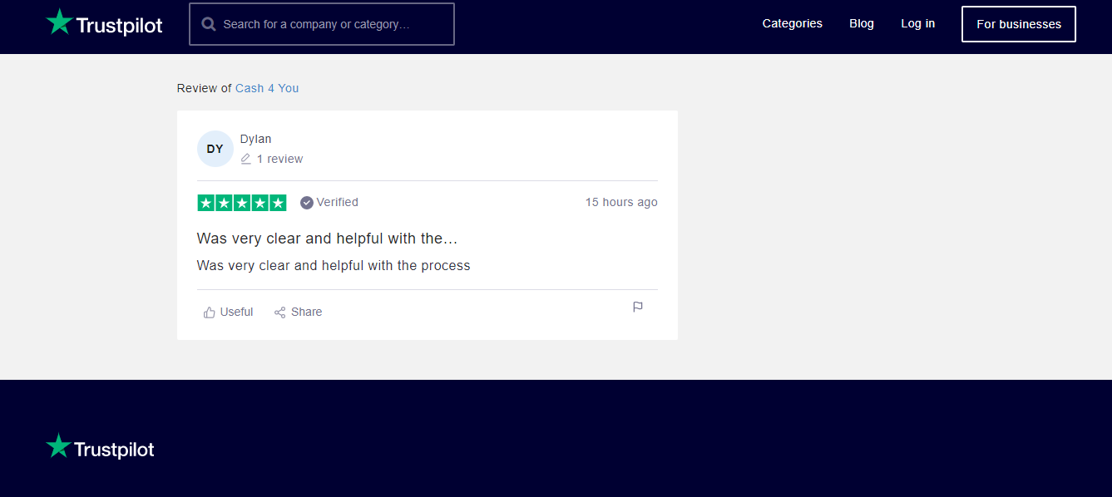

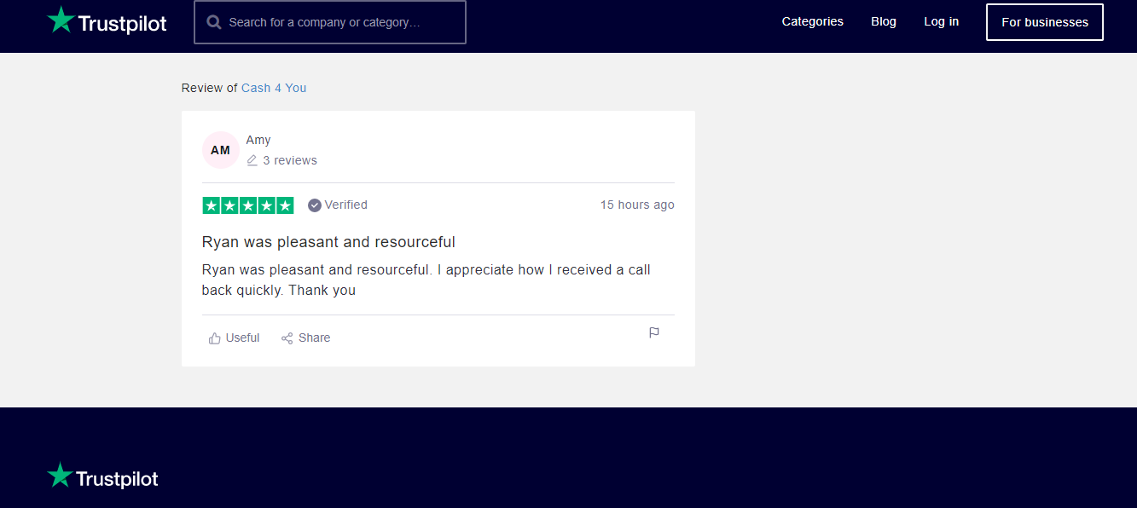

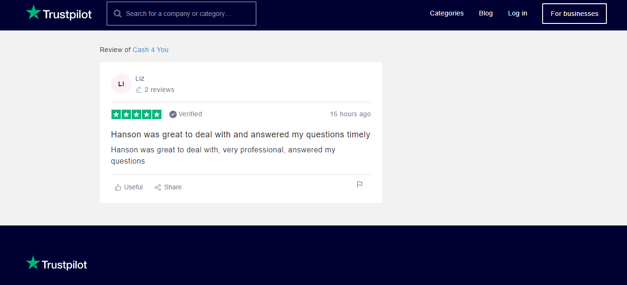

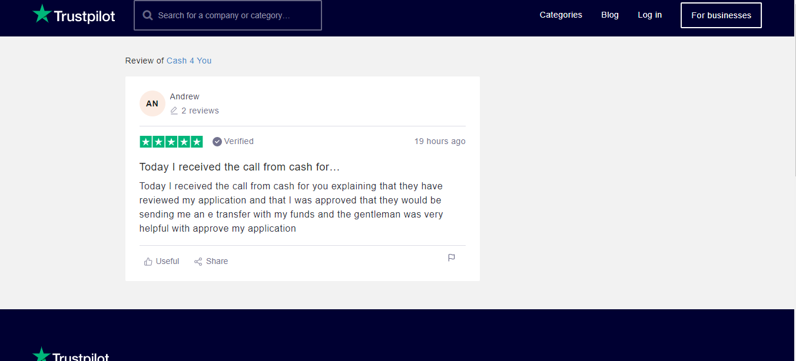

**Where are Cash 4 You stores located?**

Some of the common stores include Cash 4 You Windsor, Cash 4 You Barrie, Cash 4 You Newmarket, Cash 4 You North Bay, Cash 4 You Welland, Cash 4 You Oshawa, Cash 4 You Whitby, Cash 4 You Niagra Falls, Cash 4 You Thunder Bay, Cash 4 You Hamilton, Cash 4 You Brockville, Cash 4 You Brampton, Cash 4 You Kingston and many more.

You can always browse for other stores.

**Some shortcomings of the Cash 4 You Lender**

* The loans have high interests at 46.93%
* The stores are only located in the Ontario region.
* For those who applied for installment loans online, you’ll still be required to visit a physical store for document verification.

**Conclusion**

The Cash 4 You is a great place to borrow a loan, cash a cheque or carry out an online money transfer.